**Business Analytics Project**

**FAU Women’s Soccer Analytics**

**Introduction:**

In the dynamic world of sports, analytics has become an indispensable tool for understanding player and team performance. Performance analysis is an emerging discipline in football. It uses technological tools to evaluate the performance of players in an objective way.

**Purpose of the project analysis:**

This FAU Women’s Soccer Analytics Power BI project aims to provide comprehensive insights into the performance of players and the team using key metrics such as goals scored, assists, shots on goal, saves, goals allowed etc. by leveraging the power of data visualization. These analytics provide important insights to the team’s manager and the coaching staff, so that they can make key decisions which improves the performance of the team and the players.

**Describing the dataset which I have selected:**

The Dataset consist of Event Data from all the 18 league games played by our FAU Women’s Soccer team this 2023 season.

Event Data records a data point for every touch of the ball in a match, for example every pass, shot or tackle. This data can either be captured live or post-match, and can be coded manually, by an analyst at the match or in a remote office, or this data collection can be assisted by computer vision.

**Link to the Dataset:**

The Dataset for each game is available in different Pdf’s. So, there are totally 18 pdfs in total for all the 18 games this season. I have downloaded all the PDFs from the FAU Women’s Soccer page. Steps to download the pdfs are shown below:

Step 1 🡪 <https://fausports.com/sports/womens-soccer/schedule/2023>

Step 2 🡪 After you land on the above page select the box score option to find the pdf to download.

Step3🡪 <https://dxbhsrqyrr690.cloudfront.net/sidearm.nextgen.sites/fausports.com/stats/wsoc/2023/pdf/20230823122354-261363.pdf>

Step 4 🡪 Download all the 18 pdfs of the 18 league games this season.

After downloading all the PDFs, I’ve imported them into the Excel file, performed data cleaning and organized the data into a usable format.

**List of Columns:**

1. Position
2. Player
3. Shots
4. Shots on Goals
5. Goals
6. Assist
7. Minutes Played
8. Saves
9. Goals Allowed
10. Played As
11. Opponent
12. Date
13. Match
14. Assist Per90
15. Assist-to-Goal-Ratio
16. Goal Involvement
17. Goal Allowed Rate
18. Saves Per 90
19. Shots per Goal

And there are 353 rows in total after cleaning and converting the pdf.

**Analysis Methodology followed:**

1. I have used Power BI for my analysis due to its ability to create interactive dashboards that dynamically explore player statistics, team performance and match dynamics. This analysis with Power Bi can be presented to coaches and players to discuss strategies, analyze performance and set goals.
2. I have created the below visualization Max of Assist per90 by Player and Player, by selecting the Player in X-Axis and Assist Per90 in the Y axis, and I have also dragged the Player to the Legend. I have used the below mentioned formula for the column Assist Per 90:

**Assist Per90 = (Total Assists/ Total Minutes Played) * 90**

This Visualization shows that how much a player is Assisting in a game which is 90 minutes. In the below visualization we can see **Drew Dempsey has 5.63** of Max of Assist per90 which means she is making nearly 6 Assist per match.

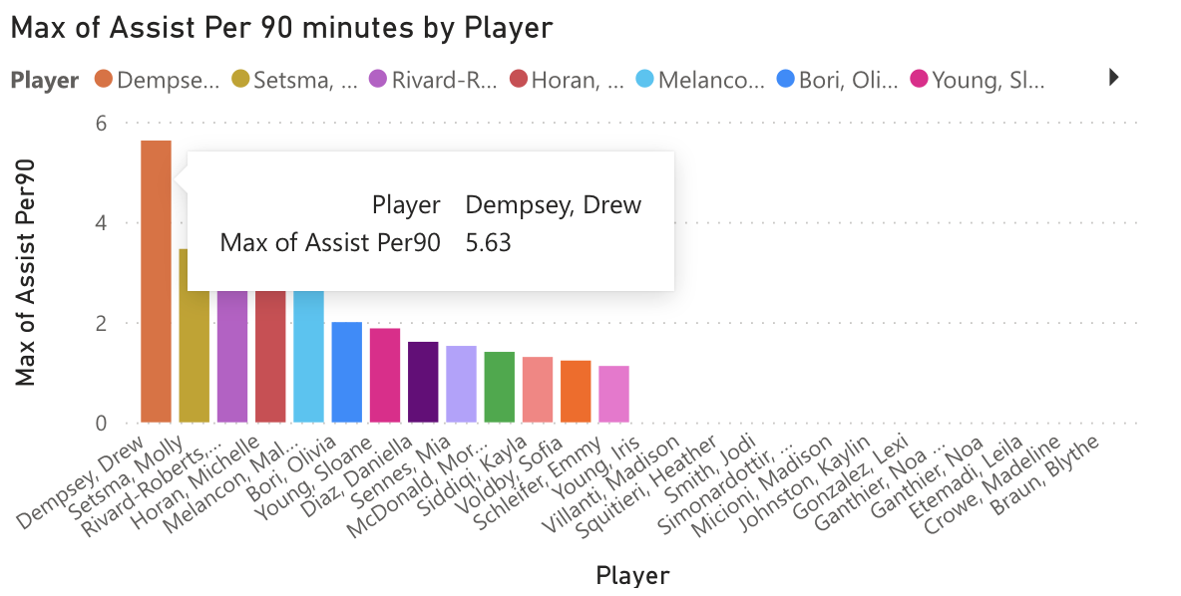

The below visualization represents the Average minutes played by a player in a match throughout the season. Here we can see Jodi Smith plays average of 81.88 minutes a match throughout the season.

**Dashboard 1** 🡪 **Goal Analysis**

**Dashboard 2** 🡪 **Assist Analysis**

**Dashboard 3** 🡪 **Goalkeeper Analysis**

**Analysis Result:**

|  |  |  |
| --- | --- | --- |
| **Dashboard 1 - Goal Analysis** | | |
| **Positive Insight** | **Negative Insight** | **Any other analysis and comments** |
| 1. The visualization **Sum of minutes played by Position** clearly shows that which position have played maximum minutes the whole season and its percentage. For eg- The Mid fielders have played 6231 minutes the whole season which is the highest among all positions. 2. The visualization sum of goals by Opponent shows the total num of goals scored by an opponent against FAU from which the team can see how many goals they have conceded against which opponent. 3. The visualization sum of Goals and sum of Shots on Goal by Player showcases how many goals have been scored by a player throughout the season. 4. And the same visualization sum of Goals and sum of Shots on Goal by Player demonstrates the shots taken by player on target which is a very important metric in soccer when it comes to soccer analysis. | 1. The visualization **sum of Goals by position** clearly shows the negative insight in terms of the total number of goals scored are 13 for midfielders and the FWD have only scored 6 goals throughout the season which is a huge concern for the team. The FWD are mainly for scoring many goals but here we can see the MID players have scored highest number of goals this season. |  |

|  |  |  |
| --- | --- | --- |
| **Dashboard 2- Assist Analysis** | | |
| **Positive Insight** | **Negative Insight** | **Any other analysis and comments** |
| 1. The visualization Max of Assist Per 90 by Player shows how much a player is Assisting in a game which is 90 minutes. In the visualization we can see Drew Dempsey has 5.63 of Max of Assist per90 which means she is making nearly 6 Assist per match which is an amazing number. 2. The second visualization Average of goal involvement by Played As showcases the average goal involvement by Starters and Substitutes which means we can see who are making a good impact in the game, the starters or the substitutes in the whole season. Here in the visualization, we can see the players who start has 50.91 Goal involvement average and even substitutes are doing well since they also have 49.09%. 3. The visualization Sum of Assist by Position shows the players playing in which position have Assisted maximum number of times. Here we see FWD 15 assists, MID 6 assists, DEF 2 assists throughout the season. 4. The sum of shots on goal by match shows the maximum number of shots on target on each match which is again an important metrics in decision making. | 1. On comparing the two visualizations Max of Assist per90 by player and Average Goal involvement by Played AS shows that either a player who plays as a starter throughout the game or came in as a substitute is not performing well in terms of providing many assists and engaging in goals involvement. |  |

|  |  |  |
| --- | --- | --- |
| **Dashboard 3- Goalkeeper Analysis** | | |
| **Positive Insight** | **Negative Insight** | **Any other analysis and comments** |
| 1. The Average of Goals Allowed Rate by player explains the average of goals allowed by the goalkeeper in all matches. Here, Lexi Gonzales has only 35.99% of Goals Allowed rate which is pretty good for a goalkeeper for the whole season. 2. The visualization Sum of Goals Allowed by Match shows the goals conceded in each match. Here we can see the team have conceded 3 goals in match 3 and 0 goals in Match 10,11,13,16,17,4 and 7. 3. The graph Sum of Saves by Opponent explains the saves made by the goalkeeper against each opponent throughout the season. In here we can see Goalkeeper has made 11 Saves against Utsa. 4. The 4th visualization Average of Minutes played by Player represents the Average minutes played by a player in a match throughout the season. Here we can see Jodi Smith played average of 81.88 minutes a match throughout the season which is nearly a full match which is 90 minutes. | 1. The negative insight which I see from Sum of Saves by Opponent is, even though the goalkeeper has made 11 saves vs UTSA and nearly more than 5 saves in half of the matches it shows the weakness in the defense in few matches which made the opponent have a shot in the goal more than 5 times. |  |

**Conclusion:**

These dashboards can be used by the coaching staffs to analyze performance of each player and the overall team so that they can work on fixing their forward players attacking gameplay which I see as a disadvantage in the team. And they should also plan on using the right players on right time for greater impact. Moreover, it helps the coach, and the staffs make some crucial decision on their formations and game plans next season so that they can clinch the title in the upcoming 2024 season.